**Karan Arora**  **R.L. Institute M: 9416974837**

**Max Time : 1 hr** **Class = 10th Science Test Max Marks : 25**

**ELECTRICITY**

1. What is the maximum resistance which can be made using five resistors each of (1/5) Ω ?

|  |  |  |  |
| --- | --- | --- | --- |
| a) (1/5) Ω | b) 10 Ω | c) 5 Ω | d) 1 Ω |

1. What is the minimum resistance which can be made using five resistors each of (1/5) Ω ?

|  |  |  |  |
| --- | --- | --- | --- |
| a) (1/5) Ω | b) (1/25) Ω | c) (1/10) Ω | d) 25 Ω |

1. A student carries out an experiment and plots the V-I graphs of three samples of nichrome wire with resistances R1 , R2 and R3 respectively, Which of the following is true ?

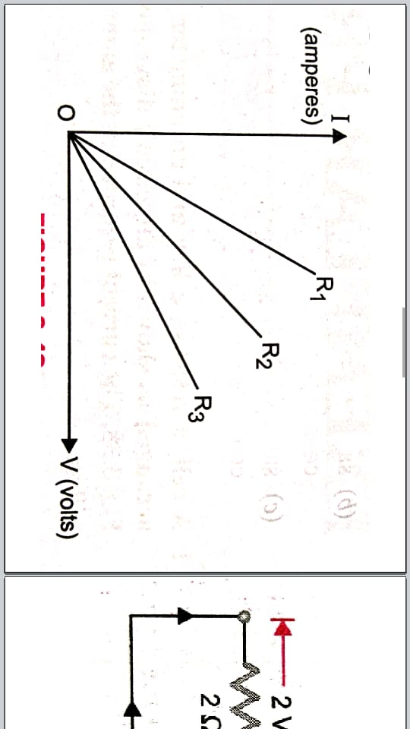

|  |  |  |  |
| --- | --- | --- | --- |
| a) R1 = R2 = R3 | b) R1 > R2 > R3 | c) R3 > R2 > R1 | d) R2 > R3 > R1 |

1. Calculate the current in a wire if 500 C charge is passed through it in 2 minutes. [ 1 ]
2. A bulb of resistance 600 ohm is connected to 220 V mains. Calculate the magnitude of current.

[ 1 ]

1. Define 1 Ampere. [ 1 ]
2. Write the unit of resistivity. [ 1 ]
3. Calculate number of electrons present in 32 C of charge. [ 1 ]
4. Define Ohm’s law and draw V – I graph. [ 2 ]
5. Three resistor of 2 Ω , 3 Ω and 4 Ω are connected in (a) series (b) parallel. Find the equivalent resistance in each case [ 2 ]
6. A parallel combination of three resistors takes a current of 7.5 A from a 30 V supply. If the two resistors are 10 Ω and 12 Ω , find the third one. [ 2 ]

Or

Define Potential difference and write its formula and unit.

1. Define Conductor and Insulator with example. [ 2 ]
2. Write any two characteristics of series combination. [ 2 ]
3. Write the factors on which Resistance of a conductor depends. [ 2 ]
4. A cylinder of a material is 10 cm long and has a cross-section of 2 cm2. If its resistance along the length be 20 Ω , what will be its resistivity in numbers and units ? [ 2 ]
5. The resistivity of copper is 1.76 x 10 – 8 ohm m. The radius of the wire is 1 mm . Calculate the length of a telegraph wire needed for having a resistance of 10.5 Ω . [ 3 ]